Test Case: tc002_SPX_Dev5_Crear_Requisicion_Spot_Tipo_Cobro_Project
Step 1 - Enter username and password and click to button Enter: Credentials Entered
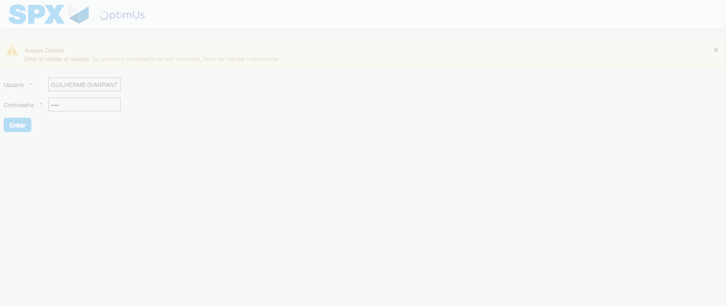Image file-name: QC_Testing-tc002_SPX_Dev5_Crear_Requisicion_Spot_Tipo_Cobro_Project-1784309667071

Step 2 - Select to UEN and Access to Spot Buy Requisitions : UEN Correctly selected and Correct access
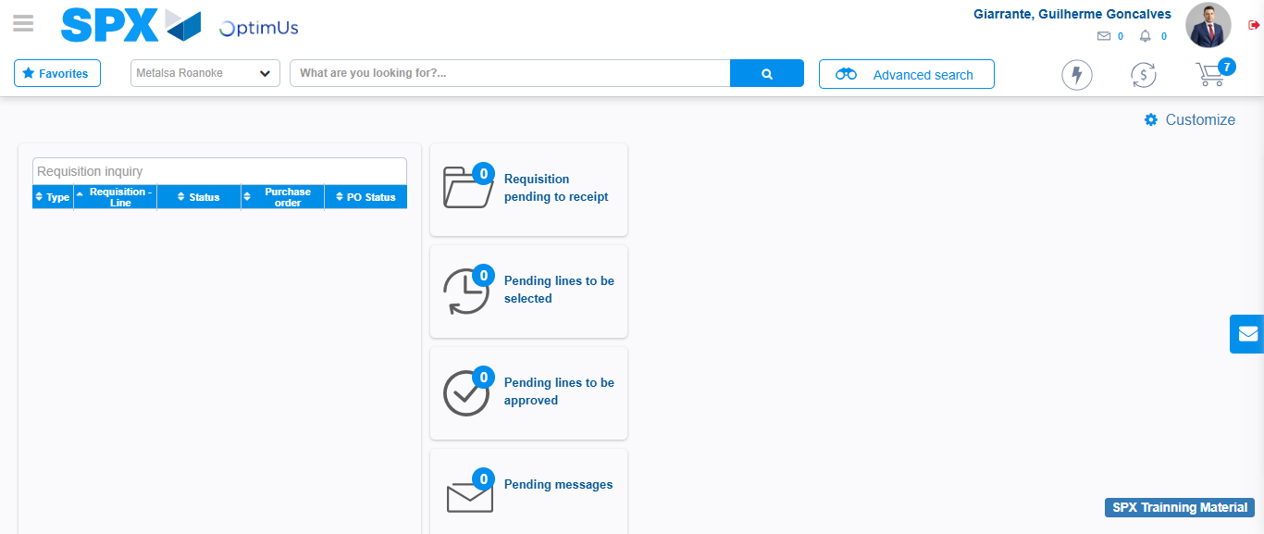Image file-name: QC_Testing-tc002_SPX_Dev5_Crear_Requisicion_Spot_Tipo_Cobro_Project-1784309693509

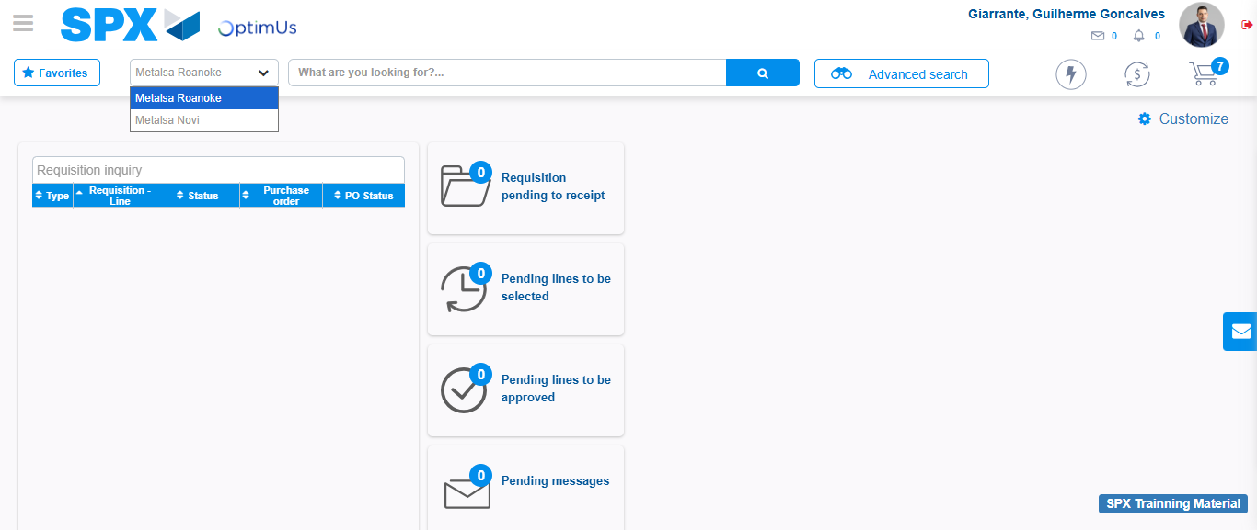Image file-name: QC_Testing-tc002_SPX_Dev5_Crear_Requisicion_Spot_Tipo_Cobro_Project-1784309696200

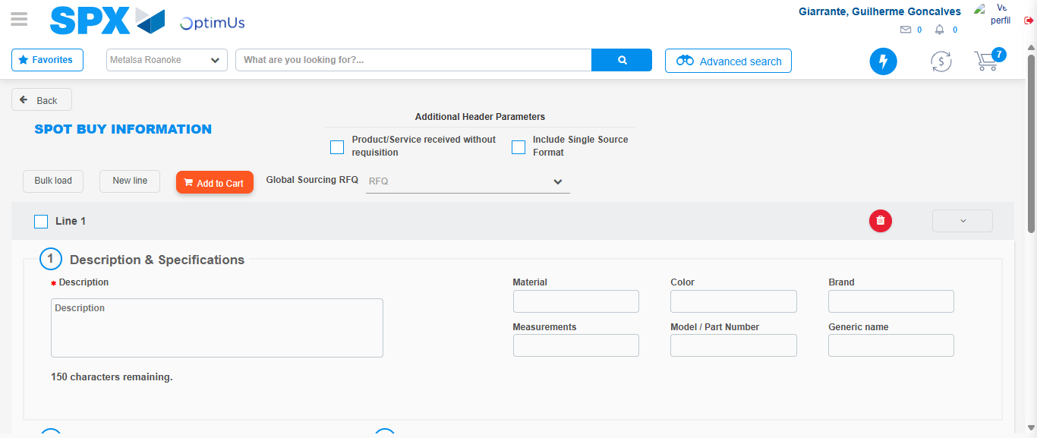Image file-name: QC_Testing-tc002_SPX_Dev5_Crear_Requisicion_Spot_Tipo_Cobro_Project-1784309715091

Step 3 - Data Capture Spot Buy Requisition: Data captured correctly
Image file-name: QC_Testing-tc002_SPX_Dev5_Crear_Requisicion_Spot_Tipo_Cobro_Project-1784309715373

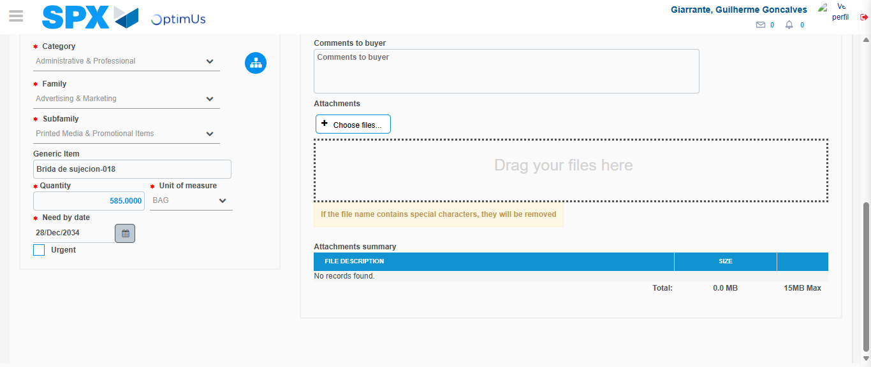Image file-name: QC_Testing-tc002_SPX_Dev5_Crear_Requisicion_Spot_Tipo_Cobro_Project-1784309728086

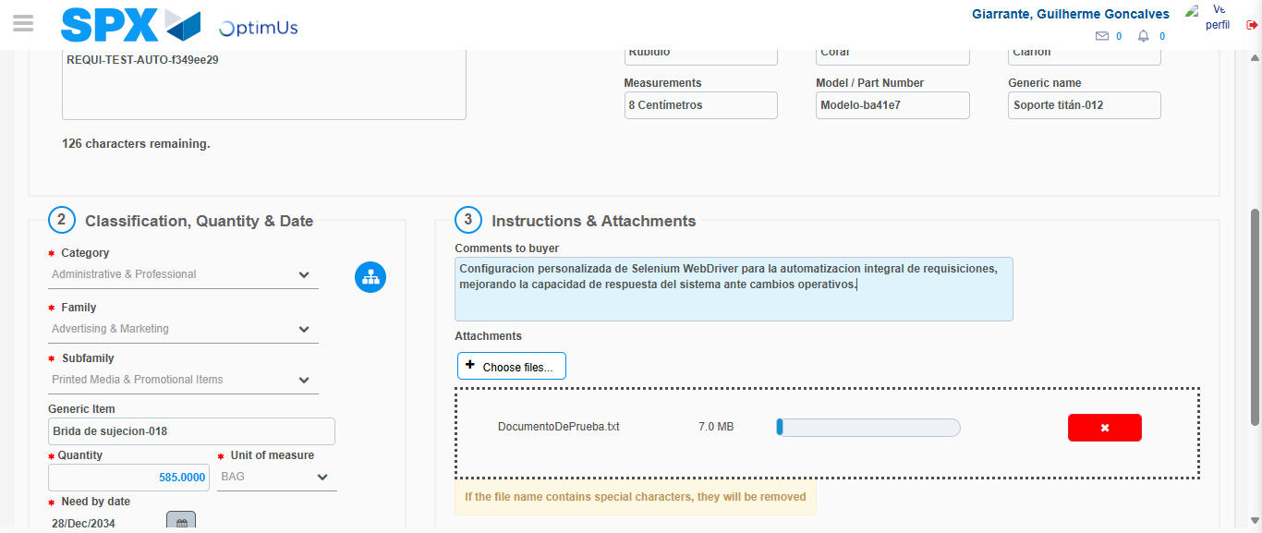Image file-name: QC_Testing-tc002_SPX_Dev5_Crear_Requisicion_Spot_Tipo_Cobro_Project-1784309729067

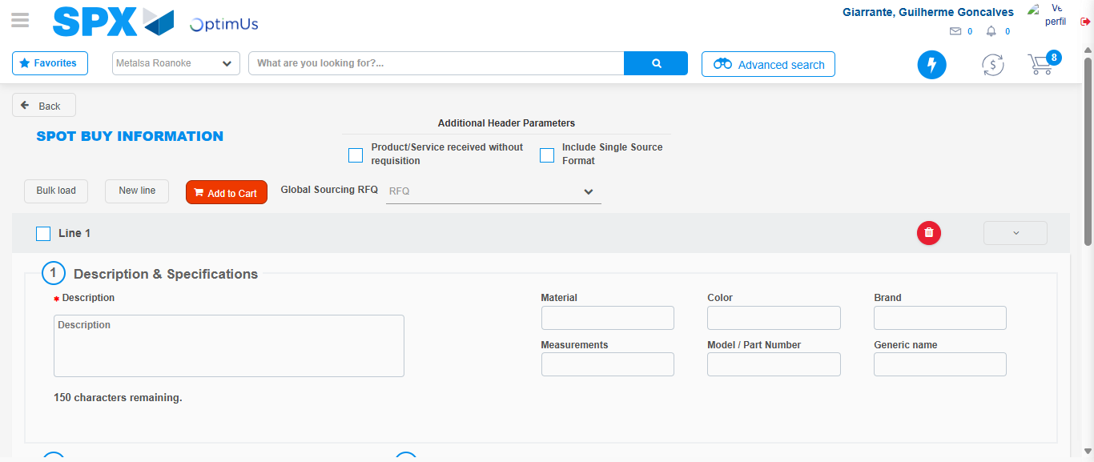Image file-name: QC_Testing-tc002_SPX_Dev5_Crear_Requisicion_Spot_Tipo_Cobro_Project-1784309734458

Step 7 - Return to Main Page SPX : Return to Main Page SPX
Image file-name: QC_Testing-tc002_SPX_Dev5_Crear_Requisicion_Spot_Tipo_Cobro_Project-1784309693509

Image file-name: QC_Testing-tc002_SPX_Dev5_Crear_Requisicion_Spot_Tipo_Cobro_Project-1784309696200

Image file-name: QC_Testing-tc002_SPX_Dev5_Crear_Requisicion_Spot_Tipo_Cobro_Project-1784309715091

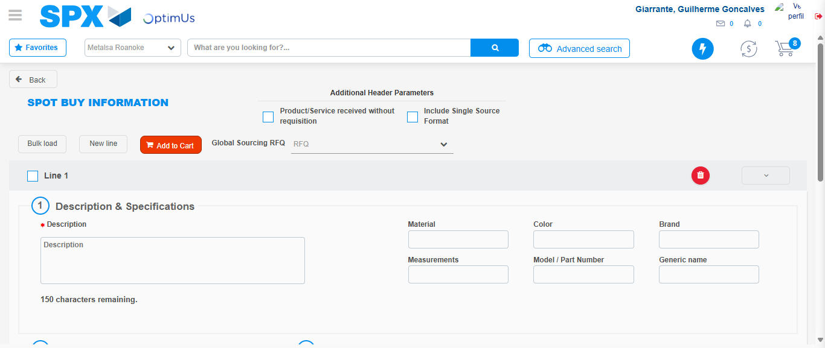Image file-name: QC_Testing-tc002_SPX_Dev5_Crear_Requisicion_Spot_Tipo_Cobro_Project-1784309736753

Image file-name: QC_Testing-tc002_SPX_Dev5_Crear_Requisicion_Spot_Tipo_Cobro_Project-1784309736962

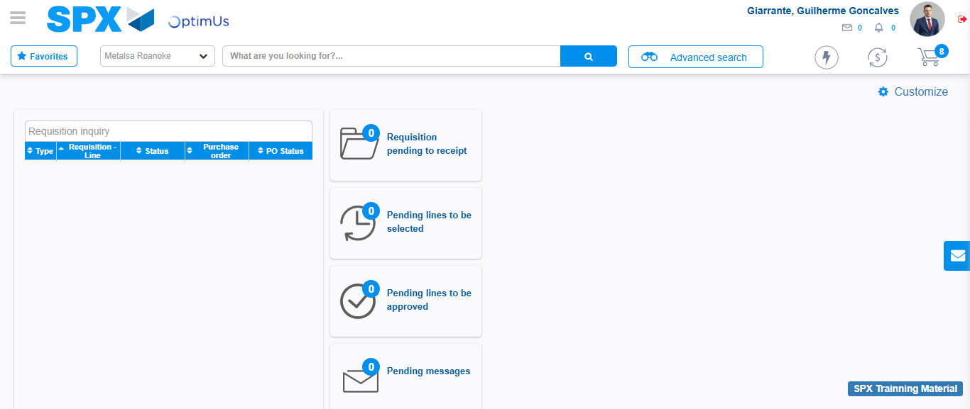Image file-name: QC_Testing-tc002_SPX_Dev5_Crear_Requisicion_Spot_Tipo_Cobro_Project-1784309758046

Step 8 - Log Out : Log Out SPX
Image file-name: QC_Testing-tc002_SPX_Dev5_Crear_Requisicion_Spot_Tipo_Cobro_Project-1784309758283

